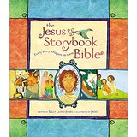
Jesus Storybook Bible is a wonderful children’s bible with beautiful illustrations that could be a very simple tool to use to share a bible story with kids in your micro church.
The bible itself is written in a poetic fashion and every story eludes to Jesus and his coming kingdom at the end.
There is a website below here which is from a blog that compiles an activity to go with each story in the bible. The link itself is linked with other websites that have the activities for each story.
http://www.mymundaneandmiraculouslife.com/jesus-storybook-bible-hands-activities/
This is a very simple way to add some form of teaching to your micro church without adding too much complexity.

Here is a link as well to the actual bible on amazon: https://www.amazon.com/Jesus-Storybook-Bible-Every-Whispers/dp/0310708257/ref=sr_1_1?ie=UTF8&qid=1469041623&sr=8-1&keywords=jesus+storybook+bible

