MICRO CHURCH ASSESSMENT
By Brian Sanders

STATEMENT | STRONGLY AGREE | AGREE | NEITHER AGREE NOR DISAGREE | DISAGREE | STRONGLY DISAGREE
1. People who come to your group would describe it as an experience with God. | 5 | 4 | 3 | 2 | 1
2. You have someone new engaging your group at least once a month. | 5 | 4 | 3 | 2 | 1
3. When you look at scripture together people are often amazed. | 5 | 4 | 3 | 2 | 1
4. Your people know and celebrate each other’s birthdays. | 5 | 4 | 3 | 2 | 1
5. Jesus is always explicitly honored whenever you gather. | 5 | 4 | 3 | 2 | 1
6. Prayer never seems forced or difficult in your group. | 5 | 4 | 3 | 2 | 1
7. There are people who would say they have come to faith in Jesus because of your group. | 5 | 4 | 3 | 2 | 1
8. There is a strong sense of family in your group. | 5 | 4 | 3 | 2 | 1
9. If a non-believer interacted with your group three times they would have heard the gospel. | 5 | 4 | 3 | 2 | 1
10. Most everyone in your group would say that they have learned to be more intimate with Jesus because of being involved with you. | 5 | 4 | 3 | 2 | 1
11. Most of the group knows each other’s middle name. | 5 | 4 | 3 | 2 | 1
12. It is not uncommon for people to cry and be embraced in your group. | 5 | 4 | 3 | 2 | 1
13. When your group is talking about scripture or in prayer people often lose track of time. | 5 | 4 | 3 | 2 | 1
14. Everyone in your group is a part of recruiting and including outsiders to the group. | 5 | 4 | 3 | 2 | 1
15. If a couple in your group was going to get married everyone in the group would be invited. | 5 | 4 | 3 | 2 | 1
16. You often talk about you call to reach people, love others or do ministry outside of the gathering together. | 5 | 4 | 3 | 2 | 1
17. If someone in your group had a crisis they would bring it to you. | 5 | 4 | 3 | 2 | 1
18. You have seen people not only grow in your group but grow into leaders themselves. | 5 | 4 | 3 | 2 | 1
19. If someone in your group was having an affair it would be obvious. | 5 | 4 | 3 | 2 | 1
20. When you look at scripture as a group it is not just an intellectual exercise, it engages everyone’s hearts. | 5 | 4 | 3 | 2 | 1
21. Someone who was once a part of the group as a non-believer has since come to lead someone else to Jesus. | 5 | 4 | 3 | 2 | 1

CATEGORY SCORE
ADD scores for statements 1, 3, 5, 6, 10, 13, 20 to get you WORSHIP score.

___ +___ +___ +___ +___ +___ +___ =

ADD scores for statements 4, 8, 11, 12, 15, 17, 19 to get you COMMUNITY score.

___ +___ +___ +___ +___ +___ +___ =

ADD scores for statements 2, 7, 9, 14, 16, 18, 21 to get you MISSION score.

___ +___ +___ +___ +___ +___ +___ =

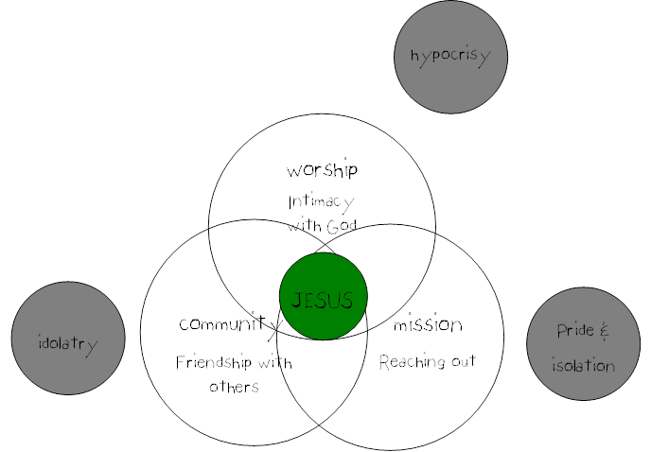Limiting Church
These three components when happening together make up the church. As I have said before, some things that we have called church, by this definition are not. And some things that we have not called church are. If we depict these three components as concentric circles we can see that not only are we capable of doing just one (or none for that matter) it is possible to do combinations of two of the components at a time. It is possible to be a part of a group that worships together but whom do not know each other on any significant level and who do no mission together. Some churches are just warehouses for worshipers. People come in once a week, unconnected and unsent, they return each week to sincerely present themselves to God in worship. This is a wonderful thing. But it is not church.

Likewise, a community of Christians can exist on a softball team, or school classroom, or neighborhood. People can share their lives in a deep way but never pray or worship together and never participate in mission. This kind of community can be beautiful and deeply encouraging, it is a good thing. But it is not church.

Or a group of people can gather to participate in the mission of God. Feeding the homeless once a week, doing street evangelism, or door to door, or building a home for a single mother. This group of people could be doing a great service and see people won to the kingdom of God. But they are not relationally connected, not sharing their lives and they do not submit themselves to God together. This kind of ministry is excellent and can be very effective. But it is not church.

While each of these three things individually are good, when they are isolated from the others or when our spiritual experience is limited to just one of them we face particular pitfalls. God has configured the church to be a refuge for us. He has called us into the church because it helps us to live as Jesus lived. Jesus was committed to these three things and really little else. Jesus did not have committees, or music, or building, or take up offerings. Jesus was not married, he did not have children, he did not have a big house or a nice car (or donkey or whatever). So none of these things can be a requirement for being a follower or being the church.

Just Worship: Hypocrisy
If our spiritual life is confined to a privatized worship that is sincere but does not lead us into mission or into deep relationships with others we face the threat of hypocrisy. As we are offering ourselves to God but then not putting into practice what his presence and his word would naturally require.

Just community: idolatry
If we pursue deep relationship but fail to live those relationships in the light of the mission of God or submit those relationships to the headship of Jesus then we risk idolatry. Deep relationships that are unmediated by a concern for the kingdom and mission of God will take over our hearts taking a place that should only belong to God. These unbalanced relationships will quickly become unhealthy and detrimental to our spiritual life.

Just Mission: Pride
If our spiritual life is confined to independently pursing mission but not open, accountable friendships or dependence on God the we risk becoming our own God. Taking the mission on ourselves without realizing our need for God or the people of God will certainly lead to error and egomania.

The Overlaps
Combining two of the three gets us closer to being church but because each of these three things is a minimum our life together is not church unless it embodies all three. Some churches are places of worship and community. People know and love each other and present themselves to God in worship every week together. Most of what we call church looks like this. But if mission is not a part of what is happening, no amount of pomp and circumstance, ritual, or sacraments can make it church. Churches that are non missional can become trivial, self focused and hyper critical. The lack of engagement of mission will emphasize the programs for believers and growth is only possible through entreating Christians from other churches.

The overlap between worship and mission is sometime represented by para church organizations, mission agencies and city ministries. A mega church can also fit this category. It is possible that an extremely large church could encourage participation in worship together and occasionally in mission ventures to the city or the world. But the people still remain unconnected and unknown to each other. This overlap can be effective for the kingdom but the absence of community keeps it from being sustainable as their people are susceptible to burn out and high turn over rates. Mission without community is painstaking and tedious.

Secular mission agencies would be examples of the third possible overlap. They may be in community with each other as they pursue a mission (they may not) but without a corporate commitment to Jesus, it could be good but it is not church as it lacks the presence of Jesus.

This view of the church is intentionally christlogical. The center of these three components is Jesus. It our commission that defines us, to go together, under his authority, to make disciples of all nations. This is what it means to be the church.

We are the church we re-present the life of Christ to the world. Our call, our identity is a continuation of the ministry of Jesus, as the father has sent me so i am sending you (collective you) into the world. we are sent, we are a part of the apostolic church sent into the world, as he was sent. and we continue his work. greater works than these will we do. this does not mean in actual miracles that are greater, but that together we will do more than he could do as one man since the way he did ministry (out of relationship) would stay the same for the church, and the church has the ability to be in millions of relationships and in so doing changing the face of humanity.

