IS IT TIME TO REBOOT THE MINISTRY? Lessons about a ministry’s life and death
By Jeremy Stephens

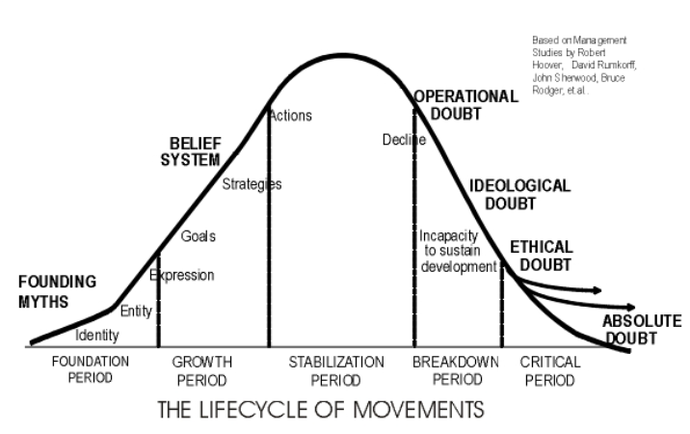
We’ve all been a part of a small group of believers who begin with passion and fresh ideas to only see that same small group decline and eventually disband. Initially when the group forms there is plenty of energy and lots of talk of making a difference. The group comes together and establishes goals, strategies and ways to express new ideas and their identity. But after a bit of time not everything that was planned goes according to plan so doubt sets in. Did the group really hear from God? Is the leadership as wise as we originally believed? What if we were wrong about our strategy? This period of what sociologists call operational doubt doesn’t feel good and, unfortunately, it’s not the end. Permanent Revolution outlines how, “unresolved operational doubt leads to ideological doubt, where we begin to no longer believe the message itself, and from there the organization devolves to ethical doubt, where we begin to behave badly because there is no good reason not to.” ¹ If doubt continues unchecked it will cause a decline in trust not only for the programs but also for the formative ideas that initially formed the group. Ideological doubt sets in soon after and inhibits creative solutions and sustainable development because the group questions, “Is this even right? Maybe someone else has better ideas?”

Alan Hirsch puts it well, “Entrenched doubt prevents us from aligning with God’s design and intent, it heralds inevitable infertility and decline in the people of God…Witness the cycles of disintegration and renewal in the stories of Israel in the Old Testament. Whenever Israel refused to follow God’s distinctive ways, it led to decline and judgment. And renewal, brought about by repentance, inevitably involved a realignment with his purposes and ushered in a period of blessing. It is no different in the church.
A doubt-filled church inevitably lacks the spiritual resources needed to empower dynamic movements. Instead of gathering a growing number of disciples, developing leaders, and adapting the organization, it will tend, rather slothfully, to rely on tired solutions arising from a worn-out, traditionalist paradigm of church—one that has patently failed in Christendom Europe, the very context that gave us that paradigm in the first place.” ¹

Every sociological gathering of people, whether a mega-church or a small group or microchurch, will experience the lifecycle of movements. No one is immune. You don’t have to come from a traditionalist model of church to find yourself rigidly grasping to your traditions and sacred cows. Each group will gather with energy, vision and ideas, quickly moving toward strategies and living out of their vibrant vision. But eventually there will be doubt, failure and decline. At this point the leaders must recognize this is not the time to “just work harder” but rather an opportunity to build the cycle back up by returning to the foundations.

Groups often function like computers. Out of the box a computer is a glorious, fast, sleek machine that is a wonder of modern engineering. But after a few years of programs, data, and hours of use…it…begins…to…slow…down. It appears broken and ready for the trash. And if you threw away your slow computer, you most likely wasted money because all it needed was to be rebooted back to its factory settings. It needs to get rid of all the extras, the digital fat, that has been collected over time. Most computers are still a quality machine if it’s restored back to its original purpose.
Just like aging computers, the solution for microchurches who have been entangled in doubt is to reboot and clear their hard drive. In other words, the group needs to realign the programs, events and structures with their foundational identity and belief systems. Only from a place of refreshed perspective and ethos can goals, plans and strategies reform. The core group of influencers need to spend significant time living in the land of vision, dreams and ideas to remember who they really are and wrestle with the core questions of why they exist. What is our vision really? What do we mean by those words? What makes us who we are, at our core?
Foundation
(re)Foundation
(re)booting your group leverages doubt to return to the foundations thus diverting it away from absolute doubt and organizational death.
Once the identity of the group is (re)established and the vision (re)clarified the group can now move toward forming programs, events and methods for implementing its renewed vision. The group will be different, a variant of the original but the core values and ethos will live on and live out the dreams Jesus imparted to the group.

TEAM TIME
Spend time as a core group mapping your journey on the Life Cycle diagram. Can you recognize seminal moments during each phase?

Can you articulate your formative ideas and dreams? Are they still relevant in your current context of ministry?

Where are you currently in the life cycle?

Where has the erosion of doubt set in? Can you be honest and identify where your programs have not lived up to the dreams of the group?

What are the minimum elements of your microchurch that must remain for your group to continue to exist? Another way to put it is, begin killing programs, events and elements to your group. What must remain for you to still have a purpose to exist?

Are there ways you can return the group to its foundations? What are the best platforms to do this work? (one-to-ones, core meetings, dreaming sessions, retreat, strategic planning, outside consultations, etc…)

¹ Hirsch, Alan; Catchim, Tim (2012-01-06). The Permanent Revolution: Apostolic Imagination and Practice for the 21st Century Church (Jossey-Bass Leadership Network Series) (Kindle Locations 727-748). John Wiley and Sons. Kindle Edition.

