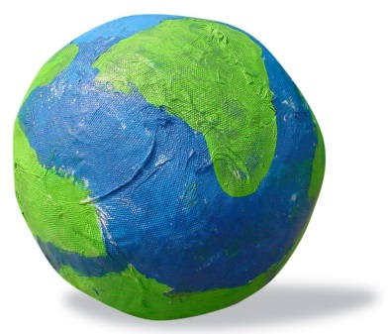

Creation Lesson: Day One

Needed Supplies: Play –doh
Construction Paper – white, black and yellow
Flashlight
Printed coloring sheet
Bible

Introduction
Playdough Creations – let the children play with Playdough – encourage them to “create” things with the Playdough – talk to them as they are creating and try to get them to name the items they are “creating”.
Bible Lesson
Read Genesis 1:1-5 aloud to the children.
“In the beginning, God created the heavens and the earth. The earth didn’t have any shape. And it was empty. Darkness was over the surface of the ocean. At that time, the ocean covered the earth. The Spirit of God was hovering over the waters.
God said, “Let there be light.” And there was light. God saw that the light was good. He separated the light from the darkness. God called the light “day.” He called the darkness “night.” There was evening, and there was morning. It was day one.”
NIrV (New International Reader’s Version)
Read the verses (story) to the children.
Read the verses (story) again using the flashlights when you get to the part about God creating light. Depending on your children, if they aren’t scared of the dark, you can even keep the lights off while you read the story again, using the flashlights for effect.
Discuss the Bible Reading
When you are finished reading the story the second time, ask the children the following questions so that you can know they understood it.
“Who was in the story?” God
“Was it dark at the beginning of the story?” Yes
“What did God create in the story today?” Light
“What number day was it in the story today?” One
Activity: Flashlight Find
“What did God create on the first day of creation? (allow for responses) Right, God created light. Without light, we wouldn’t be able to see anything because it would be completely dark.
We are going to do a game now that involves finding something in the dark, by using light. I am going to turn the lights off and hide this (name object) somewhere in the room. You have to find it by using flashlights. Ok, let’s get started!”
- Put the children in groups and give each groups a flashlight
- Have the children close their eyes or leave the room so that you can hide the object
- After you have hidden the object, let the children try to find the hidden object. Remember…they have to use the light to find the object!
Activity: Coloring Sheet
Activity: Light/Dark Paper
“We are going to make a dark and light paper to help us remember what God made on the first day of creation. First you are all going to get a white piece of paper.”
Give each child a piece of white construction
- Let the children glue the paper with the verse on it onto the white construction paper
“Now I want everyone to flip your paper over so that we can start making our paper. Do you see how your paper has a fold in the middle? We are going to glue different colors of paper on each side. God made the darkness into the light. So we are going to have a dark side and a light side of our paper. You each are going to get a piece of black paper. Now you can rip this paper into pieces and then glue them onto one side of your white paper.”
- While they are making their paper you can be writing each child’s name on their paper with the marker.
“Now we are going to make our light side of our paper. So you can do the same thing with the yellow paper that you did with the black paper. Tear it up and glue it on the other side of your white paper.”
The older kids can write the following passage on their craft: “In the beginning, God created the heavens and the earth.”
Activity: Bible Verse Memorization
“In the beginning, God created the heavens and the earth.” Genesis 1:1
(New International Reader’s Version)
Have the children do the following sign language along with repeating the words after you, to help them learn the Bible Verse:
“In the beginning”—the index finger twists between the fingers of the other hand to indicate the turning of a key in an ignition switch
“God”—hold hand up with fingers towards the sky…the hand is raised to the heavens and then downward in a sign of respect
“created”—the hands (in fists on top of one another) twist as if they were putting something together
“the heavens”—the hands move up, in a large circle, towards the heavens
“and the earth”—the thumb and middle finger pinch the side of the wrist which represents the earth rotating on its axis

