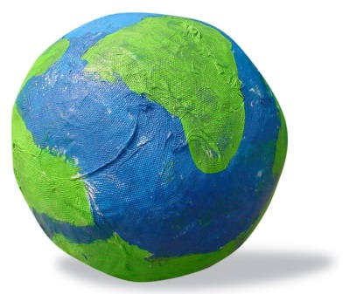

Creation Lesson: Day Three

Needed Supplies:

Bowl

Water in container

Rock

Potted plant

Apple and knife to cut it

(all the above in a bag)

Construction paper in a variety of colors

Small cups

Potting soil

Dried beans (to use to plant as a seed)

Bible
Bible Lesson
Review
What did God create on the first day of creation? heavens, earth, light
What did God create on the second day of creation? the sky to separate the water
Let’s see what happens next…
Read Genesis 1:9-13 aloud to the children.
“God said, “Let the water under the sky be gathered into one place. Let dry ground appear.” And that’s exactly what happened. God called the dry ground “land.” He called the waters that were gathered together “oceans.” And God saw that it was good. Then God said, “Let the land produce plants. Let them bear their own seeds. And let there be trees on the land that bear fruit with seeds in it. Let each kind of plant or tree have its own kind of seeds.” And that’s exactly what happened. The land produced plants. Each kind of plant had its own kind of seeds. The land produced trees that bore fruit with seeds in it. Each kind of tree had its own kind of seeds.
God saw that it was good. And there was evening, and there was morning. It was day three.”
NIrV (New International Reader’s Version)
Read the story again, but this time, bring out the items from the bag as you talk about them. Following are the words to look for:
“God said, “Let the water under the sky be gathered into one place.”
(bring out the large dish and water. Pour the water into the dish.
“Let dry ground appear.”
(bring out the large rock and place it in the middle of the dish…show the children how the water is separated)
“Let the land produce plants.”
(bring out the plants and flowers and place them on the side of the dish…they probably won’t fit inside of it)
“And let there be trees on the land that bear fruit with seeds in it.”
(bring out the apple and cut it in half to show the seeds)
Discuss the Bible Reading
When you are finished reading the story the second time, ask the children the following questions so that you can know they understood it.
“Who was in the story?” God
“What was all together at the beginning of the story?” Water
“What did God create in the story today?” The Land, Trees, Plants, Fruit
“What number day was it in the story today?” Three

Activity: Bible Verse Memorization
Then God said, “Let the land produce plants.” Genesis 1:11 (New International Reader’s Version)
Have the children do the following hand motions along with repeating the words after you, to help them learn the Bible Verse:
“Then God”— hold hand up with fingers towards the sky…the hand is raised to the heavens and then downward in a sign of respect
“said”—the index finger rolls forth from the mouth in a circular motion
“Let the land”—have hands close to body, with fingers spread out, and make a circle with hands away from the body
“produce plants”—hold one hand sideways with fingers in a form of a “c”, then “push” other hand through it as though it were a plant blooming
“Genesis 1”—hold up 1 finger
“11”—hold up 1 finger on each hand and put them side by side
Do this a few times with the children. Make it fun for them to do the motions and say the words. Involving them in active learning is essential for memorization at this age.
Activity: Making Land and Plants
Use Construction Paper to have the kids create a landscape scene (see attached pdf for a sample of the kinds of things the kids could create with construction paper)
Activity: Planting Seeds
“What did God create in our Bible Verse today? (allow for responses) Right, God made the plants. How do plants get started? (allow for responses) Plants get started from seeds. God didn’t need seeds. He is powerful enough to just make the plants without using seeds. We aren’t even close to being powerful enough as God, so we need to have seeds to grow a plant. That’s what we’re going to do today. We are going to plant a seed. You will be able to take it home and help it to grow into a plant. You will need to water it and let it get sunshine in order for it to grow.”
- Plant some seeds together as a class and they can look at them next week : )
Conclusion:
“We are going to practice what we have learned so far about what God has created.”
“First there was darkness and light” (cover eyes with hands and then release)
“Then there was water and sky” (make waves with hands & arms & then wave up in the air)
“Then there were dirt and trees” (wiggle fingers in front of you for dirt & grow up like a tree)
* Repeat the saying along with the hand motions. Then ask the children what God created on each day of creation and have them do the motions by themselves and say what He did.

